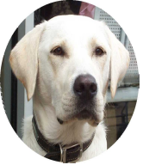
LEAD N

Magazine of Seeing Dogs

A working name of The Seeing Dogs Alliance

Training Dogs to Guide Blind and
Partially Sighted People

September 2026

Editor: Jane Anderson

Registered Charity No 1156790

A charitable incorporated organisation

T: 01634 572125 E: info@seeingdogs.org.uk
18 Court Lodge Road, Gillingham, Kent ME7 2QU
W: www.seeingdogs.org.uk
Facebook @seeingdogs
https://bsky.app/profile/seeing-dogs.bsky.social
Instagram www.instagram.com/theseeingdogsalliance/
www.linkedin.com/company/the-seeing-dogs-alliance

Index

Page(s)
Editorial by Jane Anderson 3
Trainee Seeing Dogs
Glen by John Grave 4
Bella by Jean Eastland 5
Paddy by John Grave 6
Jensen by Graham Poole 7

Seeing Dog Puppies
Dora by Emma Mann 8
Dawn by Krystyna Marshall 9

New Seeing Dog Puppies
Kim by John and Sue Ferguson 10-11
Mikey by Jane Anderson 12-13

Sponsorship of ‘Kim’. The London Marathon
By Kimberley Lane 13-14

Fund Raising and Donations 14
Christmas Cards 14
Regular and singular donations 15-16
Give as you live 16
Pets At Home 17
Promoting The Seeing Dogs Alliance 17

-------------------

Editorial

By Jane Anderson

Dear Reader,

Things are starting to cool off a bit, weather wise, although still warmer than the usual average. Things are still steaming ahead though at The Seeing Dogs Alliance. New puppies and puppies moving on to advanced training.

Hope you look forward to hearing about our first London Marathon sponsor. Have you ever thought of doing something like this?

Christmas is ever coming closer. Being asked what you would like for Christmas but you have everything you want? A donation to the Seeing Dogs Alliance may be a solution!

Christmas cards supporting us will be advertised shortly. Apologies for the delay.

Enjoy your read.

Jane Anderson
Editor

Trainee Seeing Dogs

Glen
By John Grave

Glen is a high energy, high initiative male, that wants to explore everywhere he goes and doesn’t miss anything. He works well and tries to do everything at high speed.
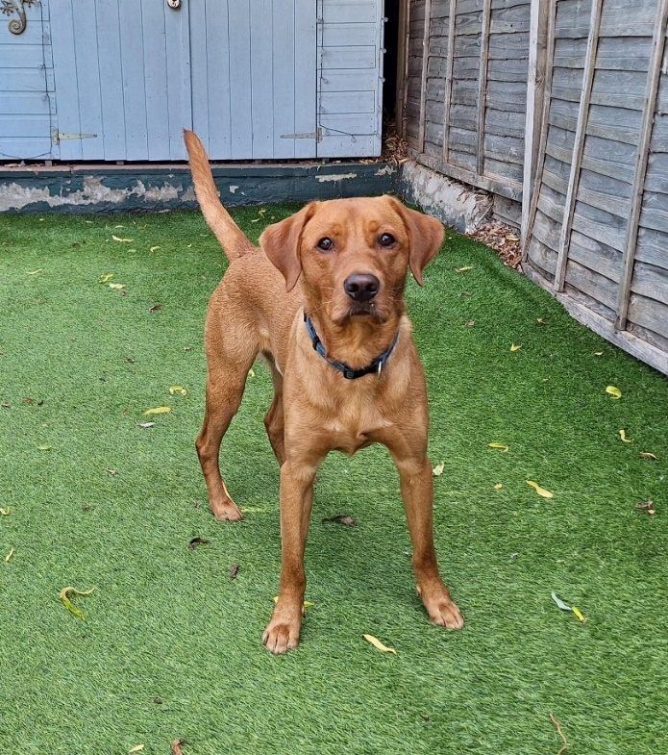  Figure 1. Glen | Spending time slowing him down by giving him lots to think about. He is working in full harness and shows good  concentration levels.
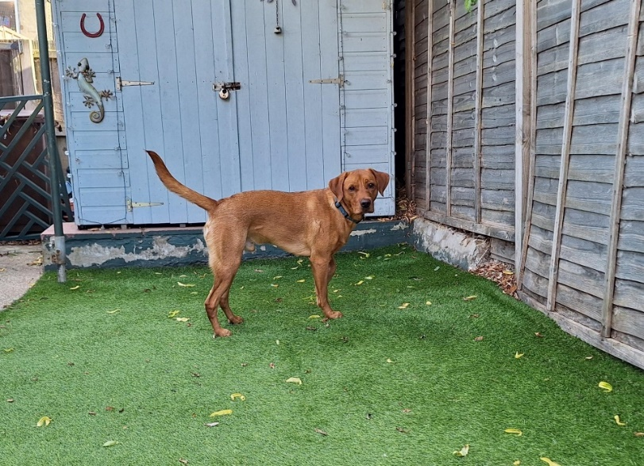  Figure 2. Glen | Glen enjoys working in busy areas and is happy to take on responsibilities albeit at a fast pace. He loves titbit training.

Bella
By Jean Eastland

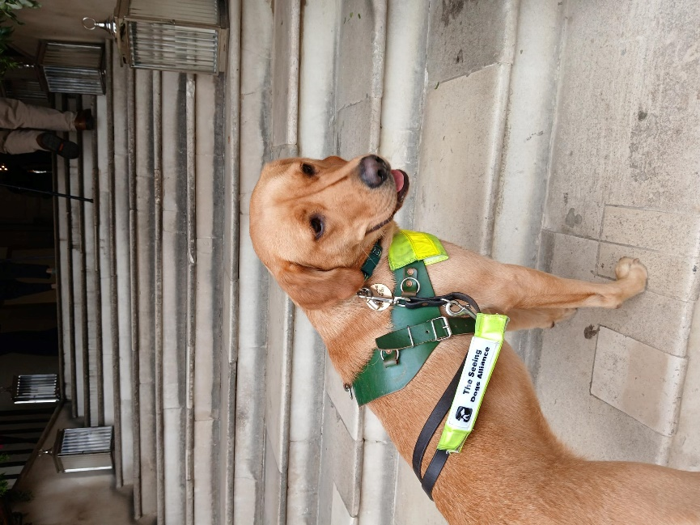  Figure 3. Bella indicating stairs | 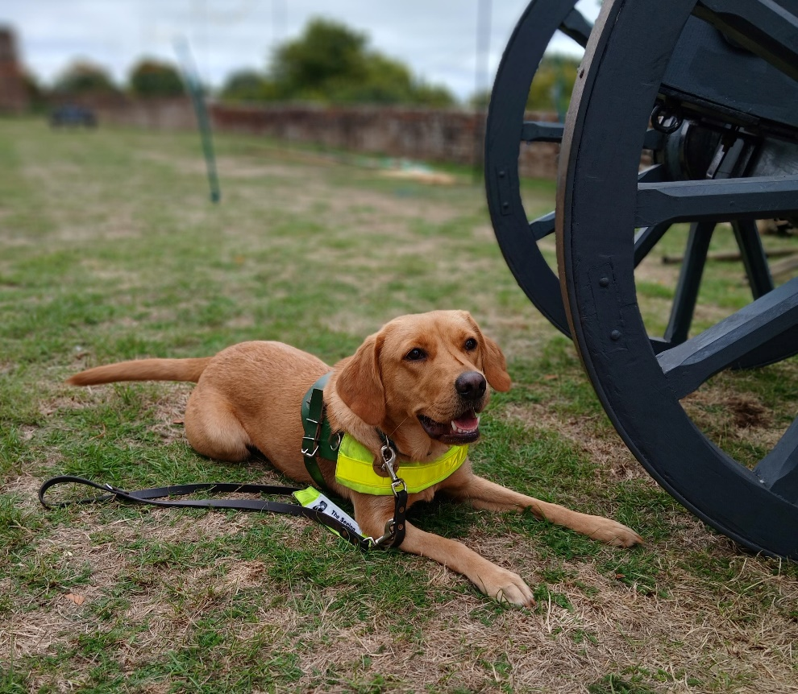  Figure 4. Bella in the lying down position

Bella has now reached an intermediate stage of her formal training. She is a healthy, happy, lively little dog and very settled at her handler’s home. She is eager to work and shows great enthusiasm to learn new tasks. She is reliable with her kerb stops and best enjoys familiar routes, when she shows good initiative.

Bella is excellent on public transport and has travelled to various locations on the local buses and train. She has been worked in rural, suburban and town conditions.
Bella is developing a good understanding of the guiding role. We are working on increasing her confidence around other dogs and people. She occasionally needs support when unsure of certain people or objects. Her confidence and decision making should improve as she matures and gains experience.

Bella is a pleasure to train and has the potential to progress further into advanced training.
Paddy
By John Grave Instructor
Paddy has only recently started his training. He is learning how to stop and sit at kerbs, walk in a straight line and learning to give a little bit of tension on the lead as we walk. He is an easy-going character and has settled in well in his new home. | 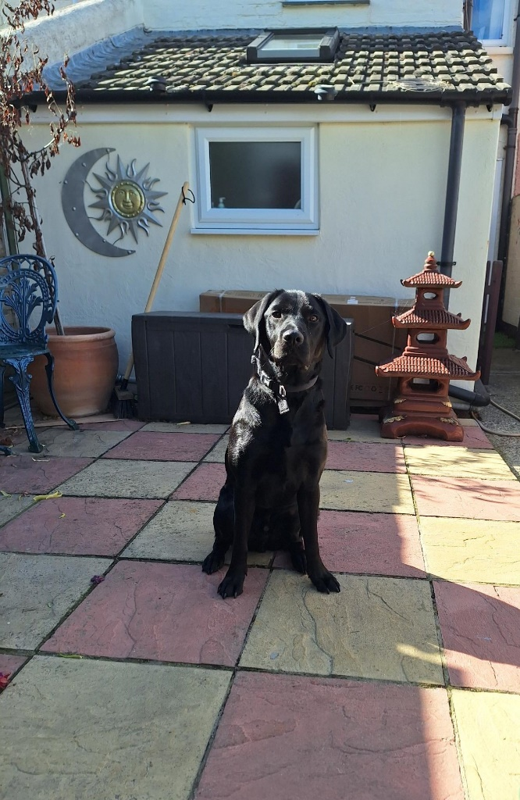  Figure 5. Paddy sitting in the Garden
He is still learning his local routes. He is happy to work in full harness and concentrates well when working. I hope to start him on obstacle avoidance and then off kerb obstacles, which I am sure he will enjoy.  He loves a free run but can be a bit naughty looking for food. A positive start. | 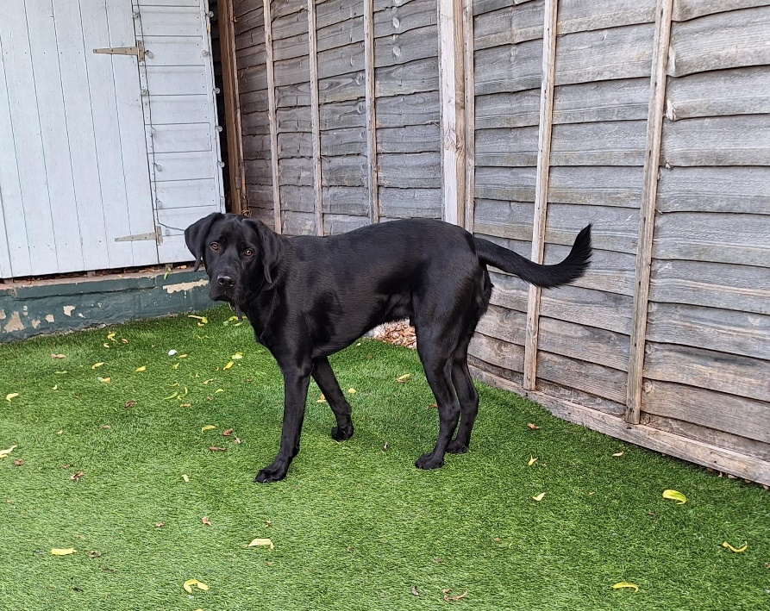  Figure 6. Paddy standing in the garden

Jensen
By Graham Poole, Instructor

I have had Jensen for getting on for 6 weeks now. My first impressions of him were of a well behaved, serious pup, who loved his food and his sleep. I immediately started working on the core basics of guiding with him, that of straight line, kerb stops and turns. Fortunately, Jensen’s distraction levels are minimal and I was able to make very good progress with him. His willingness to please has made training him relatively straightforward.

Looking forward to the next couple of weeks, now that he has readily taken to full harness and is happy to provide positive guiding tension, I am intending to train him in solid, stationary, obstacle avoidance. I am confident he will master the more complex guiding tasks as he is increasingly given more responsibility.
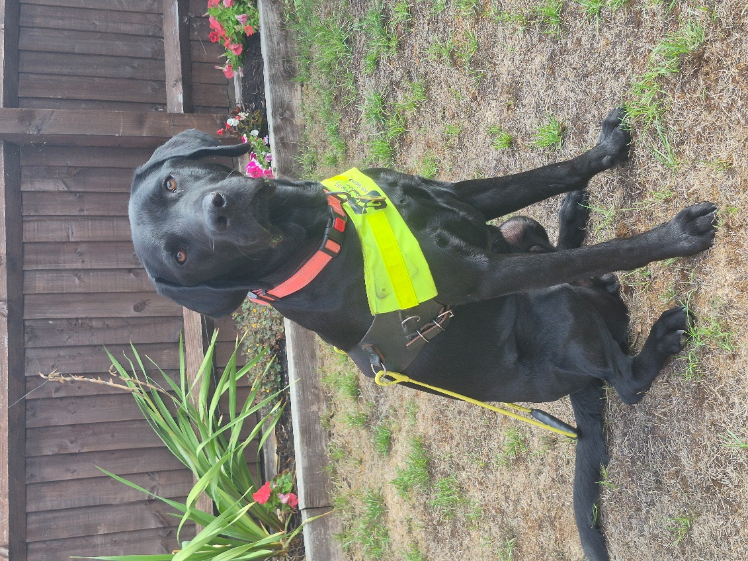  Figure 7. Jensen in the Garden | 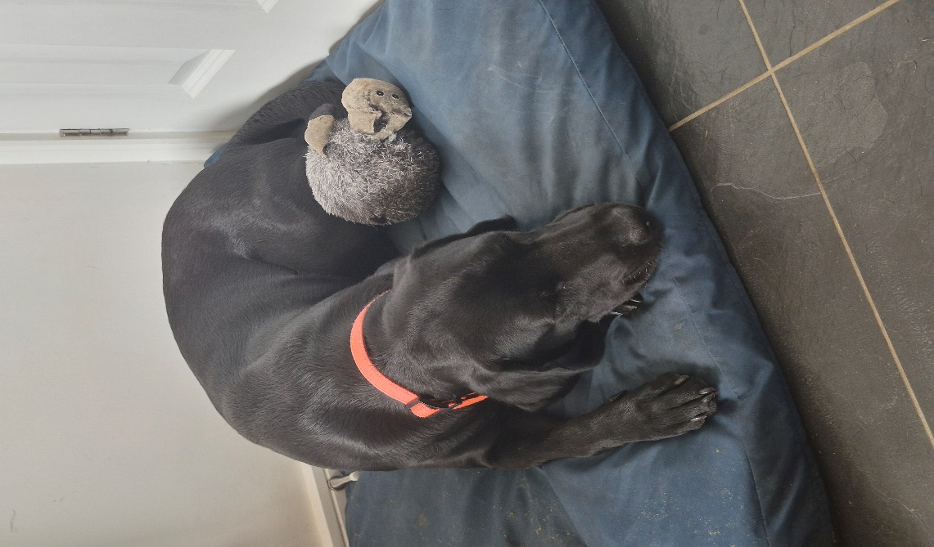  Figure 8. Jensen resting on his bed.

Seeing Dog Puppies

Dora
By Emma Mann
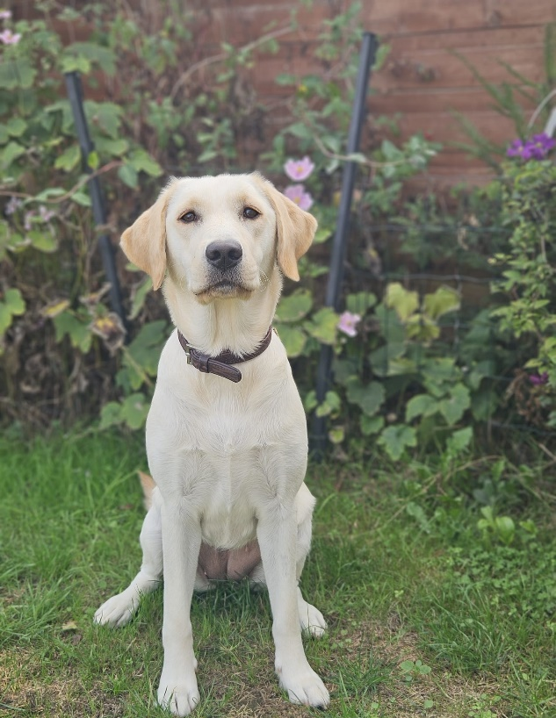  Figure 9. Dora sitting in the Garden | Dora is making good all-round progress. She has recently been spayed and recovered well.  She loves her free runs and has good recall.
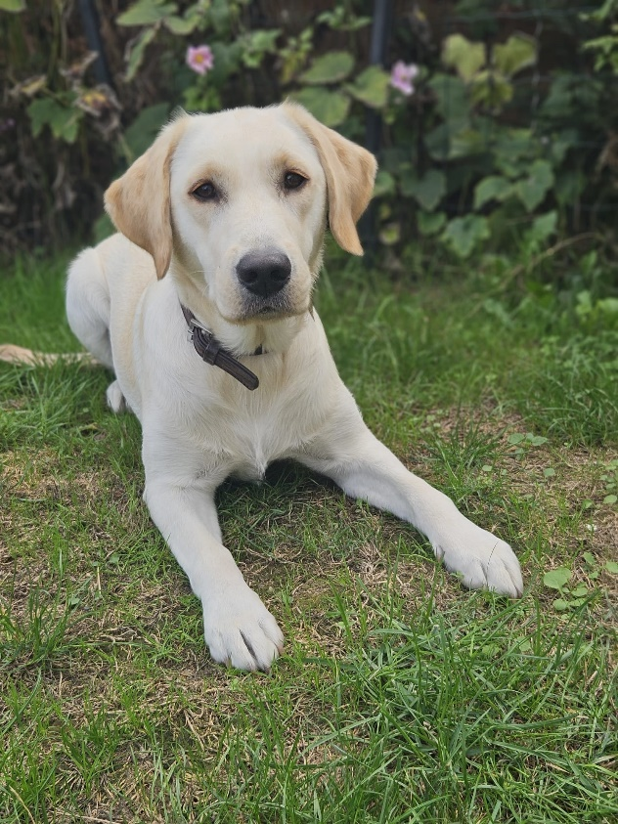  Figure 10. Dora lying down in the Garden. | Dora is making good all-round progress. She has recently been spayed and recovered well.  She loves her free runs and has good recall.

Dawn
By Krystyna Marshall Puppy Walker

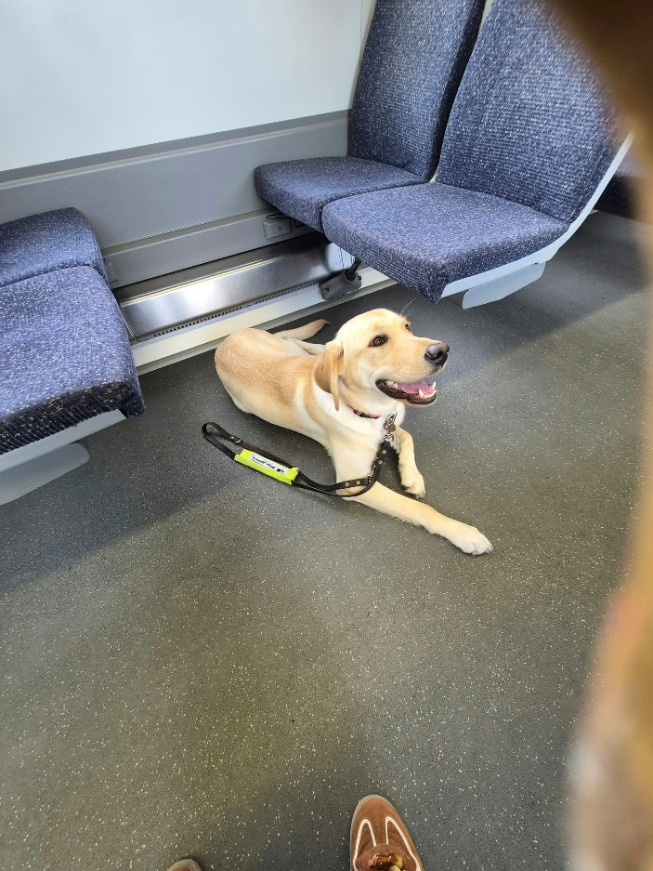  Figure 11. Dawn sitting on the train | 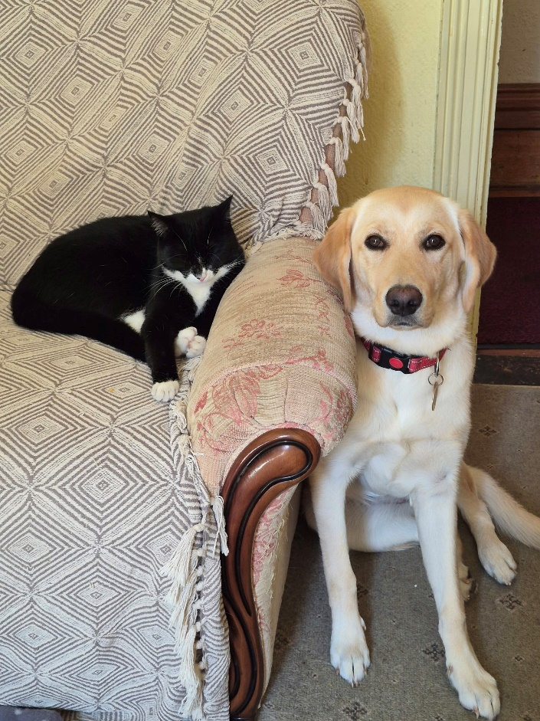  Figure 12. Dawn and 'Jam' the cat cosy in the lounge.

Dawn is 9 months old and remains a happy and curious pup, always willing to take on new experiences.
She visits busy high streets, walks briskly through the crowds but can be distracted by pigeons! She is calm in shops, and other indoor environments, although still gets excited by people approaching her to say “hello”.

Dawn travels happily on public transport and settles well for the journey.

Dawn enjoys being around ‘Jam’, the family cat and often they are found in the same room enjoying an afternoon snooze. However, she doesn’t show much interest in other cats as we pass them on the pavements.

New Seeing Dog Puppies

Kim – 8 weeks to 15 Weeks
By John and Susan Ferguson – Puppy Walkers

On 27th July 2026 our latest Seeing Dog Puppy, 8-week-old ‘Kim’ arrived at our doorstep, with the SDA Trainer John.  This male Black Labrador, is our 4th Puppy from Seeing Dogs and our 18th puppy in total, that we have Walked /Raised. Kim is a sponsored Puppy. | 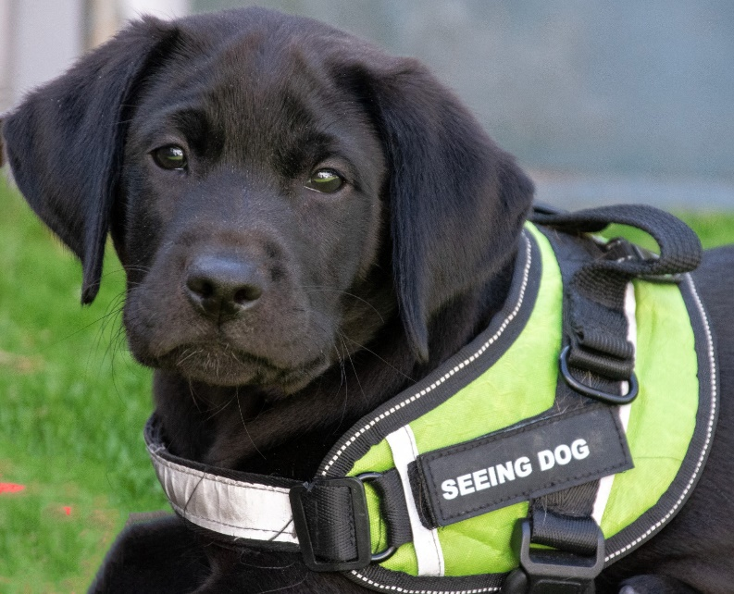  Figure 13. Kim as a young pup in Harness

We are pleased to report that Kim settled very quickly and is a gentle, calm, enthusiastic and very affectionate puppy, who has already won our hearts. Kim is equally happy engaging with us and other people and playing on his own with his toys in the garden or in the home. He sleeps well at night and is keen to learn new skills. Very much a model young Black Labrador.

Early days were spent getting familiar with his new surroundings, with the odd short trip to local shops in the third and fourth weeks of his stay. Kim showed an early aptitude for obedience training in his early play days in our garden and quickly mastered his sits and food manners. He was quickly a big hit with staff at local Supermarkets and Cafes.

When his required vaccinations were completed at around 12 weeks, he then ventured further afield doing lead walk training on nearby streets and travelling further in his car cage, for familiarization practice. He has since moved on to visiting garden and local shopping centres, where he has practiced his lead work and his settle mat work in cafes.

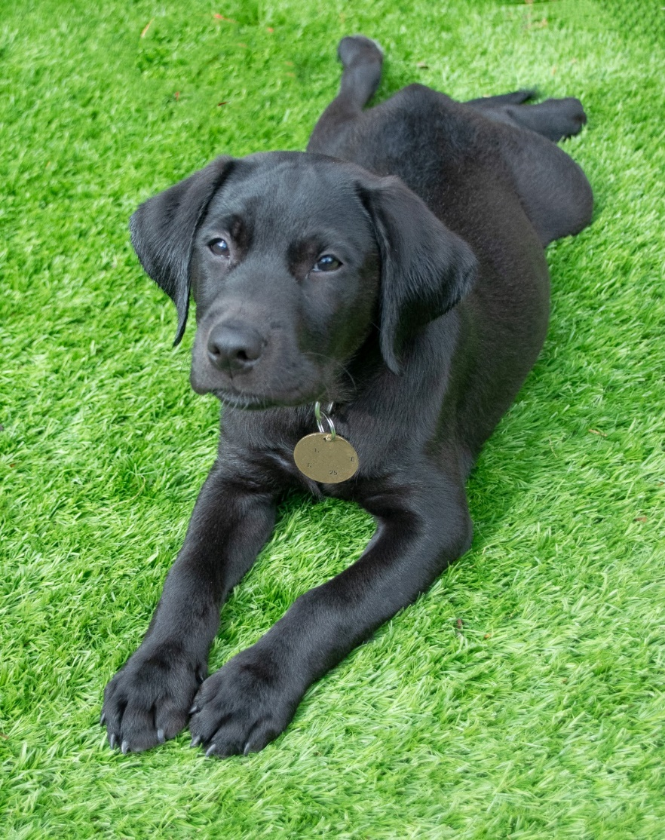  Figure 14. Kim lying on the grass | In the following weeks, Kim will experience more dog socialization, whilst on a long line in local parks and will also start his weekly puppy classes with the Trainer.  Kim has been perfecting his downs and stands, practicing steadier and slightly longer lead walks and experiencing wider scenarios. These have included a church coffee morning, a trip to Bluewater Shopping Centre in Dartford and a short trip to the seaside at Tankerton, to walk the promenade and have lunch on the grassy banks there. Kim is too young to explore the beach and sea at this time, but it’s likely this may be a surprise experience for him in the not-too-distant future.

Now, at 15 weeks old, Kim weighs around 10kg and is a fit and healthy growing puppy, that is loved by all he meets for his gentle and affectionate nature. Recall training is commencing and off lead-free running may follow soon in Kim’s time off hours from his training. So far all is good and we are looking forward to giving Kim lots of enrichment and new experiences to back up his increasing training and obedience sessions that will intensify to the next level.
Well done to young Kim. Keep it up lovely boy. We are enjoying seeing you develop and hope the positive start continues.
Mikey
By Jane Anderson, Puppy Walker

Male, black Labrador ‘Mikey’ arrived weighing 5.1kgs at the end of July and is brother to ‘Kim’.
He settled in very quickly and became friends with retired Seeing Dog ‘Barney’ and working Seeing Dog ‘Ava’, who are also in our home.

A very calm puppy who mastered basic commands of sit, lie down, come, stay and leave with ease. He is keen to learn but also happy to entertain himself. His eagerness to ‘help’ with the dead heading of plants in the garden is a little hit and miss though!
He is very good around children and the elderly alike.

Initially, he needed a lot of encouragement to walk on the lead but is now happy to proceed along local streets, visit supermarkets, shopping centres, County Shows and cafes alike.

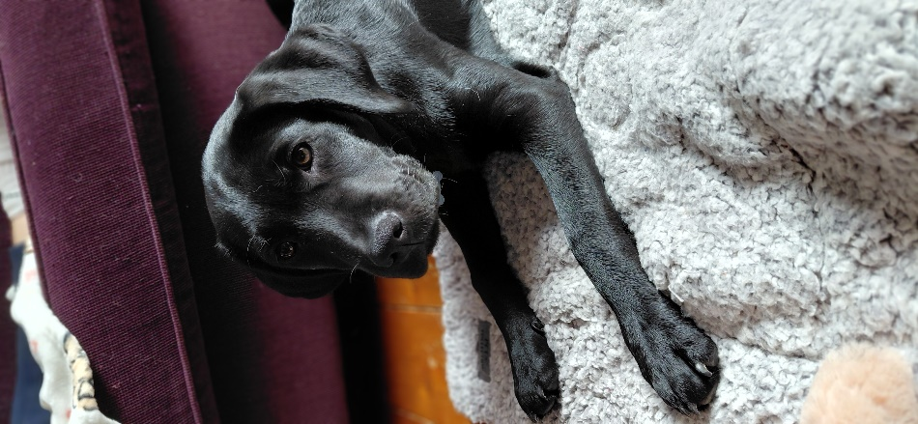  Figure 15. Mikey resting on his mat | 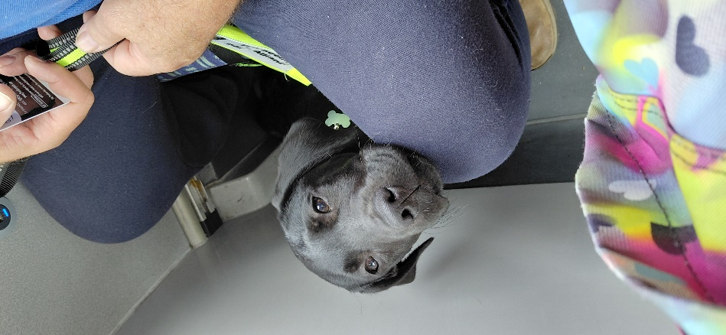  Figure 16. Mikey sitting on a bus looking very happy

Additionally, although somewhat ‘vocal’ at first, he now loves to travel in the crate in the boot of the car. He has taken several train and bus trips and is not phased at all. He has commenced puppy classes which are proceeding well.
He has very good recall on his free runs which he enjoys.

Mikey was named by our retiring Trustee Jill Sheppard.

Hoping things will continue positively with his training. Fingers crossed.
He is now 15 weeks old and weighs 12kgs.

The London Marathon and Sponsorship of ‘Kim’
By Kimberley Lane
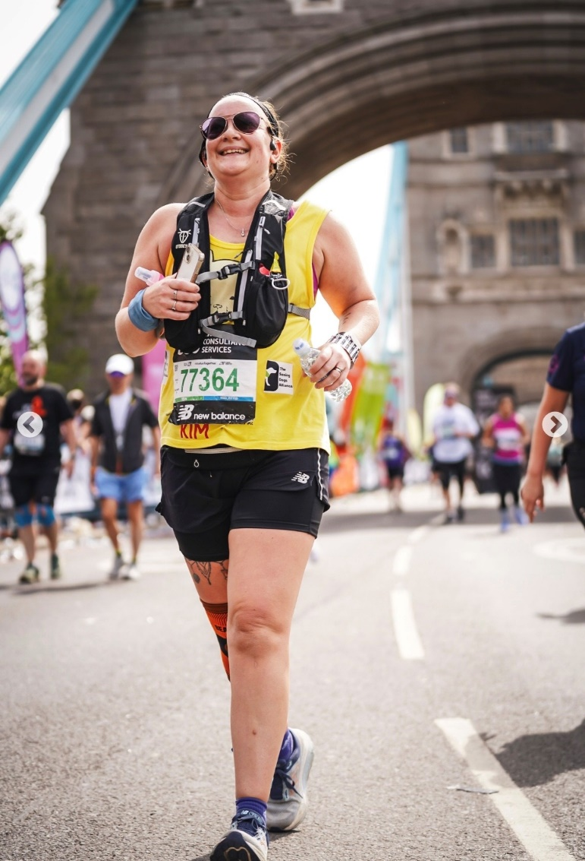  Figure 17. Kimberley on the route of The London Marathon | 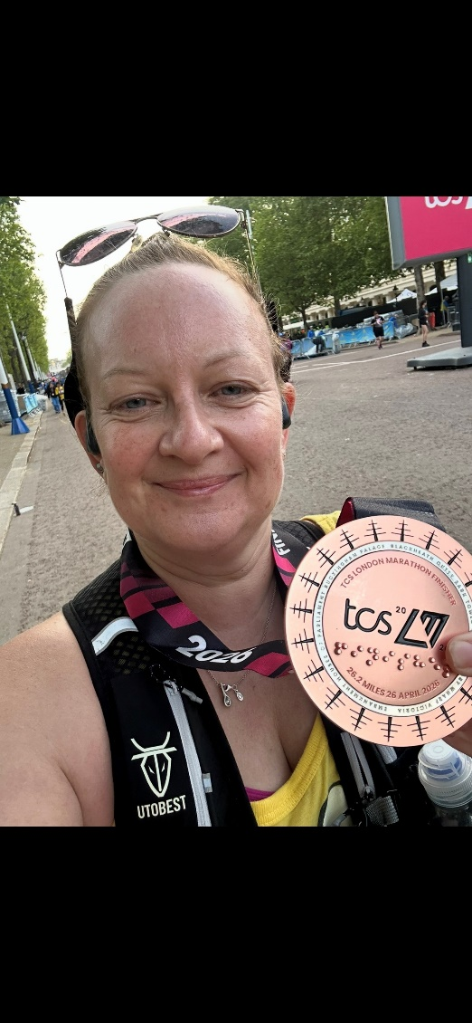  Figure 18. Kimberley with his London Marathon Medal

In April 2024, after entering the London Marathon ballot for the third year running, I never imagined I would actually get a place. Then, after losing my beloved dog and watching my brother slowly lose the sight in one eye, I received the email saying, “Congratulations, you’re in!”

My first thought was, “Oh gosh, what have I done?”
especially as I’m not a runner! 😂
I decided to take on the challenge and raise money for a dog charity close to my heart, ‘The Seeing Dogs Alliance’. When I contacted John, he was delighted and told me I would be their first-ever London Marathon runner.

I’m so proud to have raised over £1,500, and as an extra special surprise, the Charity have even named a puppy after me! 🐾❤️

I hope my story encourages others to run for this amazing charity and support the incredible work they do.

FUND RAISING AND DONATIONS

CHRISTMAS CARDS

We will once again be selling Christmas Cards to raise funds for The Seeing Dogs Alliance.
The selection to choose from will be put on the Seeing Dogs Website in about a weeks’ time.
Hope you will be able to support us.

REGULAR DONATIONS & SINGLE DONATIONS

What difference does a £5 donation make?
- £5 will pay for a puppy’s food, vet care, toys and treats for a day.
- £10 will pay for a collar and bells a Seeing Dog has to wear when it is out and about. The bells mean the dog’s partner knows where the dog is!
- £15 will pay for a grooming kit, keeping our Seeing Dogs smart and presentable. It is essential to groom our dogs to keep them healthy and looking the part.

There are several ways you can make a donation to the Seeing Dogs Alliance.

- TEXT - SEEING DOGS to 70085 and donate up to £20 per text. You will also have the option to Gift Aid your donation.
- ONLINE https://www.justgiving.com/seeingdogsYou can also donate a single amount and if desired set up a REGULAR donation.
You will also be given the option to Gift Aid your donation
- www.seeingdogs.org.uk You can also donate online via our website
Gift Aid can also be an option.
- BANK TRANSFER You can donate a single amount or set up a regular amount by direct bank transfer. Please use your name as the reference.
Our bank details are sort code 40 52 40 account number 00010645.
If you wish to Gift Aid, please forward the form on our Website to-
The Treasurer
18 Court Lodge Road,
Gillingham
Kent ME7 2QU.

- POST
A cheque, Postal Order or Charity Voucher can be forwarded to the above address.
- DONATE ANONYMOUSLY
You can send a cheque direct to Caf Bank, 25 Kings Hill
Hill Avenue, Kings Hill, West Malling, ME19 4JQ.
However, we like to acknowledge donations, so we would
Rather we know who you are.
- LEGACIES – leave a gift in your Will
With your support, a gift left in your will can provide
independence and mobility to those who don’t yet have it.
With such a kind gift we can continue to provide and train
these amazing dogs and support those who need it most.

GIVE AS YOU LIVE
Another way of raising funds for The Seeing Dogs Alliance is through ‘Give as you Live’.
‘Give as you live’ allows anyone to raise funds for their favourite charity when they shop online, at no extra cost to yourself. ‘Give as you live’ is partnered with 6,000 stores, as well as dozens of providers across insurance, energy and broadband. As a ‘thank you’ for shopping with these stores, a certain % of your spend is given to the charity of your choice. Each retailer will specify their % ‘thank you’.
There is NO EXTRA cost to yourself. All you have to do is register with ‘Give as you live’ www.giveasyoulive.com and specify your charity (The Seeing Dogs Alliance).
The thing to remember is that to get the % thank you, you MUST access the website of the store you wish to buy from, THROUGH the ‘Give as you live’ website www.giveasyoulive.com .
New stores are joining ‘Give as you live’ daily. PLEASE join up if you can.

Pets at Home
The Seeing Dogs Alliance can now be nominated as your named Charity to receive your reward points from your Pets at Home Card.  Every 500 rewards a person earns on their ‘Pets Card’, will give the ‘Charity’ one Life Line point i.e. £1.  Vouchers for the Life Line points will be issued 4 times a year, to The Seeing Dogs for them to use. |   Figure 19. Pets at Home Logo

Promoting The Seeing Dogs Alliance
The Seeing Dogs Alliance has a website – www.seeingdogs.org.uk
Facebook and an Instagram account.
Please share, follow and like all three social media outlets to spread the word. We are expanding our presence across social media, to support our drive for direct to consumer giving.
People need to know we’re here, who we are, what we do, and why they should care about us.

Would you like us to feature YOUR stories and news?
If so, please email your photos and personal stories, by
1st December 2026, to: info@seeingdogs.org.uk

